Title | Author | Goal | Key Findings | Future
From Scam to Safety: … | Tabassum, Zare, Faklaris | Investigate digital challenges and find desired solutions of educational migrants from Global south | Participants wanted reporting options, verification of threats, university tools and educations to help newly assimilated educated migrants | Design safety interventions that move throughout the digital ecosystem.
Mitigating Smishing: challenges and future works | Faklaris | Identify challenges in smishing | Device limitations, complexity of network infrastructure, context/cognitive factors | Develop new interfaces, warning systems, education, and reporting
SmishViz: … | Sanjari, et al.
Users really do respond to smishing | Rahman, et al.
What Drives Smishing susceptibility … | Tabassum, Faklaris, Lipford

From Scam to Safety: Participatory Design of Digital Privacy and Security Tools with International Students from Global South
Tabassum, Zare, Faklaris

Papers goals (pg. 2)
- Insight on educational migrants’ (EM) digital threats post migration
- Creation of safety features guided by educational migrants’ responses including AI support
- Higher-level designs overall and move beyond platform specific solutions

Themes
- EMs are more vulnerable to digital attacks
EMs face higher vulnerability to digital attacks. Can be due to multiple factors such as political situations in the US. Uncertainty, chaos, and confusion can be easier to create upon EMs making them easier targets. Cultural differences are often exploited (some cultures have more trust or regulation for digital ecosystems).
- Cross-channel and ecosystem-level scams
Using cross-channel communication and repetition often leads to the illusion of legitimacy.
- Cultural gaps in existing security tools
The global south has many cultures, some have more trust when it comes to digital demands. Some cultures also don’t experience digital threats as often due to different laws and regulations. AI-assisted systems lack the context to give EMs an understanding of what happened.
- Using participatory design (PD) to find security needs and desired features
Using PD will help reduce misinterpretation of warnings as well as an understanding of what needs to be done to protect EMs.
- Role of AI for detection, verification, and explanation
AI doesn’t include context.
- Ecosystem-level security designs
Lack of reporting and tracking the threats. Desire for apps, call filtering, or other tools and warnings to help identify real threats. Lack of training/guidance for new-comers. Full-scale ecosystem support is needed.

The Threat (against EMs)
Phishing, smishing, and vishing are designed to manipulate trust, authority, and urgency. Cross channel communication creates the illusion of legitimacy through repetition and timed coordination. Impersonations involve acting as a university, immigration office, delivery service, or financial institution. From the participants, they described the threats as asking for personal information and financial assets (SSN, unspecified PII, money). Threats were creating urgency and claiming fake credentials (IRS, DHS, jobs/housing) possibly for intimidation.
Threat delivery sources and illusional covers
- Fake immigration agents
- I-9 Form scams
- Scam emails
- Smishing
- Phone calls
- Social media messaging
- IRS
- DHS
- Housing companies

Mitigating Smishing: Challenges and Future Work
Challenges to mitigate smishing (came from the abstract word for word)
- Limitations of mobile device affordances
Attacks are difficult to detect due to technical limitations.
- Complexity of network infrastructure
Hard to solve due to complexity of text messages. Hops several times before reaching the intended destination. Back end systems will struggle.
- Cognitive and contextual factors in mobile device usage
Texts are typically considered more urgent or personal than email.

Research challenge: More studies and surveys for different groups needed (elderly, poor eyesight, less educated, time specific)

Impact → FTC (2022) → $326 million lost from smishing

Interacting with smishing messages may automatically start money transfers or send victims to fake websites to provide sensitive info. Messages often include fear, love, or greed to induce immediate actions. Attacks can span across the digital ecosystem (texts, calls, and emails to establish false authority).

Note: 76.5% of authors’ participants incorrectly guessed real messages to be fake

Solution?
- Increase awareness of existing tools and safeguards (7726, reportfraud.ftc.gov)
- Out of device market campaign to increase awareness of reporting
- In-device design for reporting tools
- In-app messages detecting possible spam/scam

SmishViz: Towards a Graph-based Visualization System for Monitoring and Characterizing Ongoing Smishing Threats

Consequences of smishing - Identity theft, financial losses, data breaches, reputation damage
FTC Q1 of 2024, $645.7 million lost in the US by fraud phone calls and messages.

Goal: propose SmishViz, graph based visualization system to observe and capture smishing campaigns and operations created by bad actors using common web infrastructures or by using similar message templates. Continuous monitoring will help proactively take defense actions against campaigns.

Gaps in current research
- Binary classification (smish or non-smish message?)
- Does not analyze relationships between messages
- Does not uncover the coordinated attack operations

Contributions/goals of SmishViz project
- Cluster messages based on textual similarity
- Group messages based on topic/theme of the message
- Visually analyze campaign operations using graphs made by D3.js
- Present case study on findings

SmishViz system - integrate live sms dataset that collects and then investigates the data to monitor the smishing campaigns.

Notes
- Smishing is a coordinated ecosystem of attacks, it’s a large scale, large reaching cybercrime network
- Texts can change but domains and url shorteners are reused consistently

Data collection (1062 pieces of data)
- URLs - 88.6% contained URLS, many looked suspicious (random characters, unusual domains)
- Brand impersonation - 65.91% of messages had identifiable brand names. 182 brands were impersonated. Notable mentions: bank of america, amazon, usps, netflix
- Web-entity patterns - typically used bit.ly and tinyurl.com to shorten and obscure malicious domains
  - Typically had character substitutions (replacing ‘o’ with 0 or ‘l” with 1)

Users Really Do Respond to Smishing

Social engineering issue - common cyber attack → costs billions a year
- Smishing, vishing, and phishing are types of social engineering attacks.
- Smartphone users are 3 times more likely to get a smishing attack compared to a phishing attack (billions of users are attacked)

Smishing can lead to ransomware, spyware, or adware installation with the goal of obtaining PII and financial information.

Goal: build on existing framework to see what makes a successful smishing attack.
- What is the success rate of smishing?
- Do different attributes of messages have an impact on the success rate of smishing?
- How does smishing impact different demographics?

The experiment targeted 265 persons using 12 different smishing texts utilizing greed and fear as tactics

First round - 260 participants targeted → 16.92% responded (clicked, replied, or called) (44)
Second round 195 participants targeted → 12.82% responded (25)

Themes
- Smishing is effective and understudied (700% increase from 2021)
- People do fall for smishing
- Different demographics are affected by smishing more often (african and mexican american)
- Some users knew it was a scam and still responded out of curiosity (31% replied STOP)
- Realism affects how effective scams are (familiar area code numbers, scams about facebook when user does use facebook, etc.)

What drives smishing susceptibility? A U.S. Interview Study of How and Why Mobile Phone Users Judge Text Messages to be Real or Fake

Goal: Understand how users judge sms messages to be real or fake, what makes users judge real or fake and how cybertraining factors into smishing.

Themes
- Users looks at content, links, and area code to judge
- Visual warnings help (on android)
- Verification and reporting failures (72.4% verify by calling the real company, 55.2% don’t report at all)
- Cybersecurity training helps classify messages correctly

FTC (2023) $327 million lost from smishing

Victims
- Younger individuals are more susceptible to Smishing
- Older individuals have higher financial losses

Question: How do individual participants perceive the credibility of SMS messages and make trust decisions? What individual and design factors seem important?

Method: interviewing 29 participants

Findings:
- Miss-spelled content, out of context messages, suspicious links failed
- Personalized messages, familiar contexts, known senders were correctly identified
- Cybersecurity training increased better judgement
- Most individuals did not report suspicious messages
- 76% of organizations in the US encountered smishing attacks (2022)

Contributions
- Enhanced understanding of individuals’ real life experiences with smishing
- Insight into cues that people use to distinguish between legitimate and fraud sms
- Design suggestions for telecommunication and mobile companies based on user data

Future
- Add warnings and filters to IOS
- Make reporting easier (7726)
- More smishing research
- Cybertraining

Phishing, Smishing, & Vishing: An assessment of threats against mobile devices

Abstract notes
The study observed 20 users and found that men who are comfortable with cyberspace were more susceptible to phishing attacks than women. iOS was the most susceptible OS to phishing attacks

Goals/Questions
- What is the extent of Phishing attacks on mobile device users?
- WHat are the characteristics of Smishing and Vishing?
- How do mobile device users fall prey or become victims of these types of Phishing attacks?

Threat motives
- Incredibly low cost to conduct these types of attacks
- Minimal expertise or education required to carry out these attacks
- Social engineering attacks are effective and have been throughout history

Early general smishing processes
- “Receiving a text message which is purported to have originated from a known and trusted source, such as your bankers or your system administrator”
- “Involves you receiving a vital text message about your identity been stolen or account number been frozen, …, directs you to a website or phone number for the verification of the account information”

Best prevention? SETA → Security education, training, and awareness
At this point in time (2014), Smishing is still a new topic that most people have not heard about. Overall, 35% of participants never scrutinized messages for threats

A Review of Smishing Attacks Mitigation

Threat
- Between March - July 2020, smishing increased by 29 percent
- Threats actors are utilizing fake phone numbers/burner phones to conduct operations since they are inexpensive and prepaid phones.
- Exploit natural security challenges in SMS such as the victims ignorance, using theft and accidental loss (9 million smartphones lost in 2011 in the U.S.), hacking, third party apps, installing malware, and other phishing-related attacks to conduct exploitation

Attacks
- Mobile malware (third party applications)
  - Used by threat actors to get our phones to download harmful software (57% increase in 2020)
  - The software tends to be free to download and install
  - Applications tend to originate from software developers selling code on the Dark web, applications then can get sent via text message in a smishing attack
- Smishing
- Vishing

Mitigation
- Education based schemes
  - Educating the general public through training, workshops, and awareness activities.
- Technology-based schemes
  - Machine learning solutions
  - Applications to detect phishing
    - Checking source code, IP addresses, and URLs
    - Filtering programs
    - Bayesian classification
    - Checking the TCP/IP stack for phishing

The Effect of Smishing Attack on Security of Demand Response Programs

Demand response systems are typically used on the powergrid system … Oftentimes some power companies will send a message (monthly, weekly, biweekly) on your total energy consumption/cost so you can reduce it and save energy overall or use more if you desire to. These messages typically come through SMS or similar.

My own example: AT&T texting me how much cellular data I’ve used (prior to having unlimited)
This article is exploring the act or possibility of disturbing DR via Smishing (DDRS) attacks

Important notes
- Smishing can damage the power grid through customer behavior even if the attacker doesn’t have a grasp on the the american power grid system
- This type of attack does not involve anything else (not even IoT) … it just requires the phone numbers of customers to power grid systems
- DR systems were created to help balance power and consumption, which is why it often uses incentives, warnings, or directions for customers.

Countermeasures
- Build an awareness plan for customers
  - Way of communication
  - Structure of legitimate messages as well as smishing messages
  - When and how to respond to messages
  - What to do if a suspicious message is received
- Utility companies creating a website for those to see if they received a valid message
- Utility companies need to cooperate with sms service providers for reporting options

Stats
- Attacks can lead for 9% voltage drop
- 11% phase imbalance
- 6% threshold

Emerging Trends in Phishing: A Look at Smishing, Vishing, Quishing

Note: quishing is code phishing (based on QR codes)

Smishing is growing due to phishing failures, and the inexpensive cost of cell phones along with its ability to be portable and always on a person.

Smishing techniques
- Spoofing phone numbers and sender IDs (police responding to non-existent calls, robberies, drugs, etc.)
- Use of impersonation, fear, rewards

Tactics in order/cycle of attack
- Information gathering: use of PAI to target persons, businesses, or other entities
- Development of relationship: building trust, impersonation of banks, government, businesses, etc.
- Exploitation: manipulation to retrieve sensitive data from the target or misleading into making security decisions.
- Execution: Termination of interaction between parties (leads to malware, SIM swap, call scams) before no contact initiated
This is the cycle of a social engineering attack

Smishing can occur through Whatsapp, facebook, skype, snapchat, linkedin and other messages and can also be used to communicate with ransomware victims

Prevention for smishing
- Verification before clicking any links or providing personal data
- INstall security applications that can detect or block malware or phishing attempts
- Regularly update operating systems
- Educate oneself on smishing tactics
- Report any suspicious activity to authorities/mobile carriers

Same type of report is made for vishing and quishing (no specific notes taken right now)

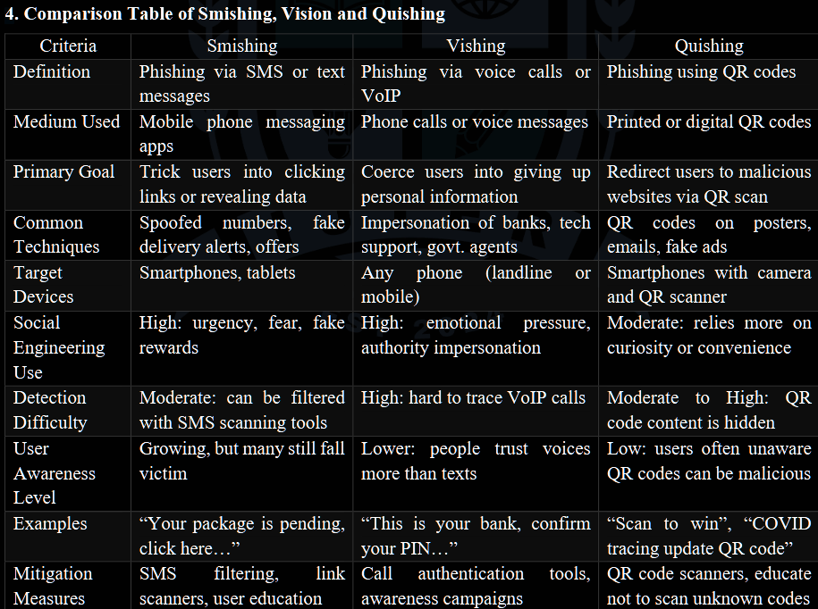

Unveiling deception: a socio-economic analysis of smishing attacks on mobile money transaction users

Note: focuses on data collected in Zambia (377 data points/persons)

Major Questions
- How does smishing target mobile money transaction users and what are the socio-economic consequences of these attacks?
- What are the user experiences with smishing attempts and how does it affect behaviors towards mobile money transactions?

Financial losses often include unauthorized transactions and identity theft from smishing attacks, not just willingly sending money over the attacker (thinking its a legitimate business)

Notes:
Financial gain is a significant motivator for cybercriminals, identity theft is often used for financial gain by cybercriminals

93% of the authors participants have received smishing in some form and 63% of them were unaware of smishing attacks.
99% of all participants said they use mobile money services

Results
- Those who use mobile money services are likely to not receive more smishing than those who do not (statistically insignificant)
- Using different mobile networks did not mean that any other service was likely to receive more smishing than those who did not (similar to above)
- Statistically significant that victims were able to note that the attackers motive were financial based
- Users that use mobile money services are more likely to be vigilant against smishing due to the financial nature of smishing messages

Prevention
- Awareness campaigns are needed to help reduce smishing and scams by the mobile companies
- Policy implementation can be created to filter sms content when scams are likely align with the creation of fraud detection alert systems

Smishing Strategy Dynamics and Evolving Botnet Activities in Japan

Note this is about Japan’s fight against bots conducting smishing

Threat (created by botnets)
- Xloader (botnet) (aka: MoqHao and Wroba)
- FakeSpy (botnet)

Smishing
- Detection is typically done by detecting illegitimate URLs, mobile botnets. The result is 95% accuracy in detection
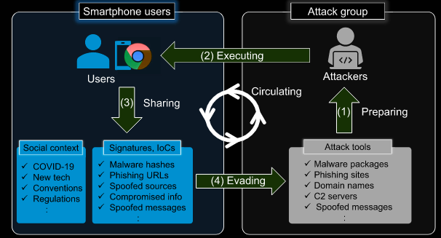
Diagram of smishing process

Smishing notes
Smishing has also affected not just PII and bank information, but also electric vehicle transition and sustainable power grid program

Smishing has increased for the following reasons
- Number of mobile device users have increased
- Mobile devices contain great deals of sensitive information
- Users immediately check incoming SMS messages
- Mobile devices are not as secure as ordinary computers
- Users are able to run their own apps and company apps on personal devices
- Infected devices contribute the spread of the infection

Smishing is also harder to detect than email (email is filtered by internet service providers, firewalls, and servers) … SMS messages arrive from many different carriers and do not have the filtering capabilities or environments created. Mobile devices have fewer resources and cannot run heavy algorithms.

Threat analysis
These specific bots are managed by a group with an unknown number of persons. They update what their smishing bots send out multiple times a day (averaging 2.25 times a day). The time of the updates indicate natural circadian rhythms with little work done on Sundays and no updates being pushed out 1300 (UTC +8). The updates are almost always the links that are sent out. 32% of these domains were created using GoDaddy.com which often requires payment information to be made. This could be used to track who and where this malicious organization operates.

S-Detector: an enhanced security model for detecting Smishing attack for mobile computing
Threat
A current issue is that smishing threat actors typically change their URLs quickly and use URL shorteners making blacklisting a harder solution.

Smishing is largely used to target many unspecified persons, but can be advanced enough to steal particular accounts in social networks and communities to send text messages to their acquaintances.

Ten Steps of the attack
- Create malicious application/web to distribute
- Target is designated and message is sent
- User clicks the URL
- User accesses the malicious creation
- Users download malicious application
- Malware installed
- Malware sends users’ PII and financial information
- Attacker uses information
- Attacker orders malicious command for secondary attack
- Users are damaged

Solution? → Machine learning algorithm: Naive Bayesian classifier based on Bayes Theorem
Morphological analyzer that helps detect smishing based on common nouns used in Smishing text messages

Threat types
- Application-based threat
  - Classified by its downloadable applications designed to steal PII and collect data (spyware)
- Web-based threat
  - Downloading malicious code from a link, typically accesses device OS
- Network-based threat
  - Data transmission by connecting to local wireless networks
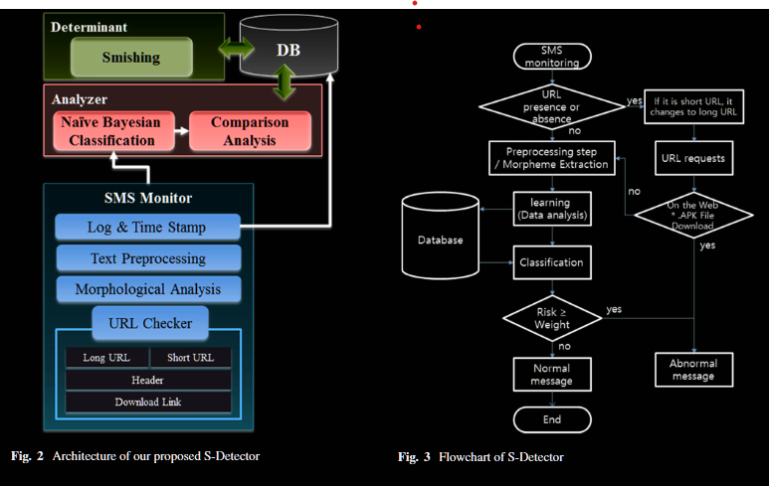

Commercial Anti-Smishing Tools and their Comparative Effectiveness Against Modern Threats
Threat
In 2021, 90% of data breaches were caused by some form of phishing (cisco), smishing has been reported by 74% of organizations (proofpoint)
Threats are using URL shorteners like bit.ly and typically purchase numerous cell phone numbers (cell phone leads) and then send mass messages through messaging services such as external short message entities (ESME)

Anti-smishing tools/attempts
Telephone Consumer Protection Act (advertisers must gain explicit consent before texting customers)
Blacklists, whitelists, greylists
ESMEs and other businesses following legal guidelines

All segments (bulk messaging services (ESME), mobile carriers, and anti-smishing apps all have gaps and need major work.
Mobile carriers reached 25-35% blocking rate (T-mobile at 35%), Verizon failed to catch any attacks at all
Apps like robokiller blocked smishing but also a lot of legitimate messages as well
Bulk messaging services did not block messages before they were sent despite claims of following legal guidelines or helping with the smishing issue.
Malicious links are often not flagged by most security vendors

SmiDCA: An Anti-Smishing Model with Machine Learning Approach
Mobile message fraud report revealed that 28% of SMS users receive an unsolicited text message everyday.

Blacklist and whitelist have major drawbacks now due to constantly changing links, numbers, and the time it takes to update these lists. Whitelists don’t work that well because every number not on the list is considered a smishing attempt.

For SmiDCA, this method uses multiple common features used in smishing and then uses a machine learning algorithm to decide if it is a smishing attempt or not. Some of these features are including a URL, e-mail id feature, phone number feature, size of message and noun frequency feature, special character feature. This proposed solution also uses correlation based on previously collected data to help determine if the message is legitimate or not. This model achieved 90% accuracy of detecting messages.

Smishing Dataset 1: Phishing SMS Dataset from Smishtank.com
1062 samples were used in this study
FCC took measures by instructing mobile providers to block messages that are deemed highly likely to be illegal

Threat
- Difficult to deal with because they change constantly (older datasets become less effective overtime)
- Impersonating high value brands is a typical tactic that is used in smishing.
- Threats often use malicious links that change often to steal or download code into a victims device
- 75.1% sent by phone number, 23.9% sent email to text
- Common brands included USPS, IRS, Amazon, Netflix, BofA, t mobile, whatsapp
- Categories were account alert, advertisements, delivery
- Most domains included .com by far followed by us, info, ly
- Common domain registers were namecheap, alibaba, internet BS corp, godaddy, namesilo

The Anatomy of a Smishing Attack: Common Techniques and Tactics used by Cybercriminals

Threat
- Attackers choose targets (end users, businesses, banks, or internet service providers.
- Smishing text generation: threats creates a message that induce trust, urgency, or emotional emotions along with malware.
- Mass texting along with strategies that include spear-smishing are sent out.
- Attackers have followthrough: attackers have a design process that will find and determine weaknesses in software, humans, online problems, or inadequate authentication
- Exploitation and information manipulation: Attackers gather important details such as identities, login information, personal data, and use the data for illicit purposes including fraud, eavesdropping, or unauthorized financial transactions. \

Countermeasures
- Awareness of security data: improving anti-smishing and smishing attack strategies, crime can be reduced through education
- Content filtering apps
- Legal measures (governmental assistance)

Cybersmish: A proactive Approach for Smishing Detection and Prevention using Machine Learning

Common weaknesses: weak passwords, misconfigured security settings, falling for phishing scams, and lack of security practices.

Other machine learning models work well but are typically only designed to look at the smishing message … message content analysis is not enough because smishing often takes victims to websites with URLs

Using lightweight transformer models like MobileBERT and DistilBERT provide higher performance on mobile device environments.

Uses 3 environments
- Message content analyzer: separates text from URL and uses MobileBERT model to classify the message in boolean values (0 for legit or 1 for phishing)
- URL analysis: uses two models
  - DistilBERT: Analysis URL content
  - XGBoost: extracts 21 features from URL’s architecture to for classification\
- HTML content analyzer: investigates destination website if message and URL are conflicting by using 2 models
  - TF-BERT analyzes text attributes <p> <h1> to <h6>
  - Evaluates 11 HTML tag features and CSS elements.

Dataset included 5574 english SMS messages
URLs collected from github
HTML dataset included 5271 phishing and 7674 legitimate websites from kaggle

A Quantitative Study of SMS Phishing Detection

Cisco reports that phishing-type attacks account for 90% of the data beaches in the United States. FTC states that $330 million lost in 2022 to text message scams.

187 participants to judge real or fake messages. Ethnicity, age, income, occupation, and comfort levels impacted accuracy in identifying real or fake messages. Scrutinizing the sender information and URL were crucial in identifying false messages.

Participants were significantly better at identifying fake messages with 67.1% accuracy than they were at real messages (43.6%). Suggests a high rate of false positives where users distrust legitimate businesses.

When identifying fake messages, the sender information and URL were the most important when identifying if the message was fake or not. Users also relied on the entity/brand name mentioned in the text.

Users with higher attention control (ATTC) and better security behavior (RSeBIS) scores have significantly better detection accuracy. Age and occupation played a role as well … students were more cautious than other groups.

Anatomy of a smishing attack
- Sender: source number or short code
- Entity: Organization impersonated (netflix, amazon, usps, etc.)
- URL/Link: malicious or legitimate destination
- Call to Action: The instruction (“click here”, “action required”)
- Scenario: Story used to trick the user (failed delivery, account suspension, etc.)

Smishing is a socio-technical problem, not just a coding failure. It is a psychological exploit

Classifying Swahili Smishing Attacks for Mobile Money Users: A Machine-Learning Approach

Automatic Detection of Smishing Attacks by Machine Learning Methods

On-Device Smishing Classifier Resistant to Text Evasion Attack

